Roblox
LEAD INFORMATION
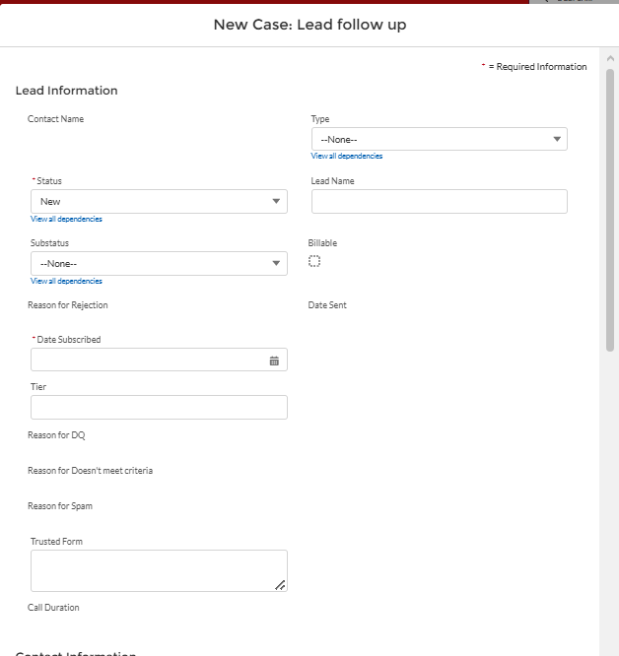

TYPE (Drop Down Options)
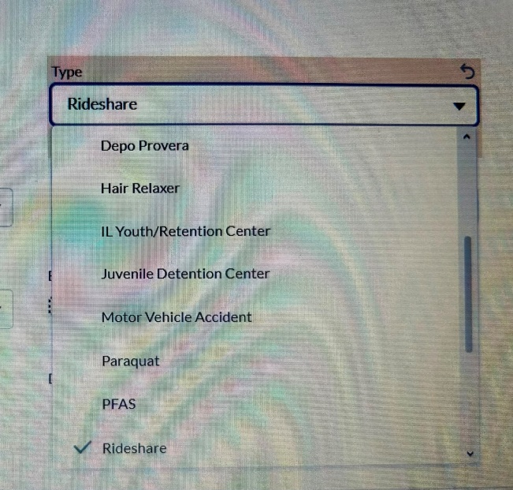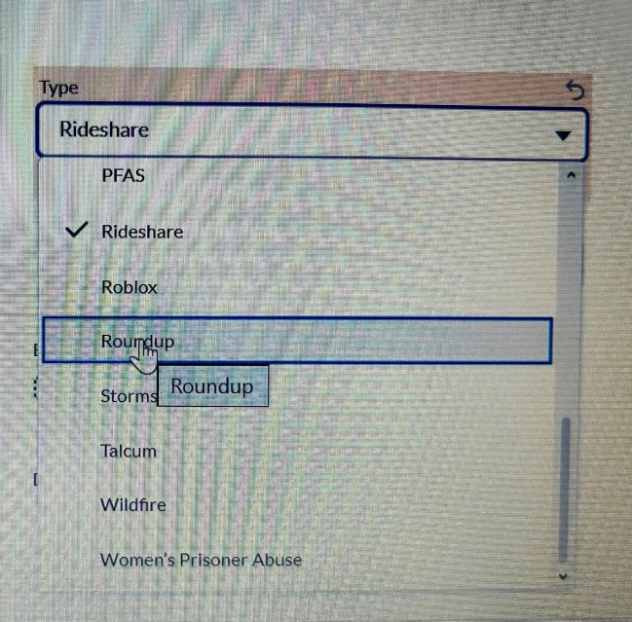
Status (Drop Down Option)
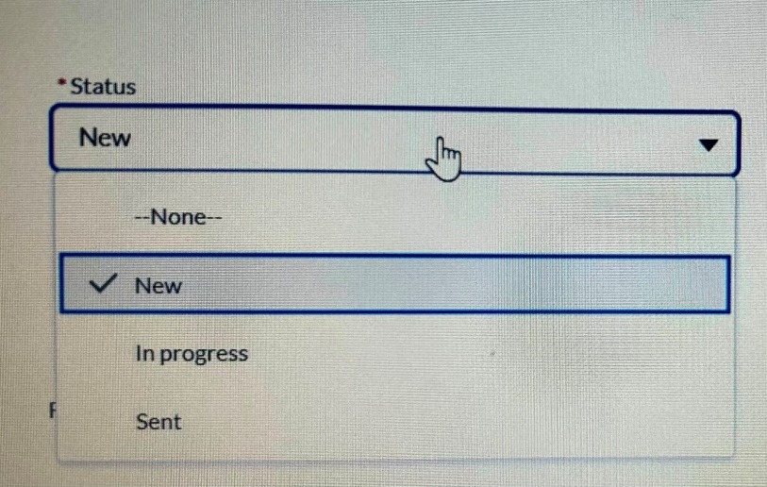
Substatus (Drown Down Option)
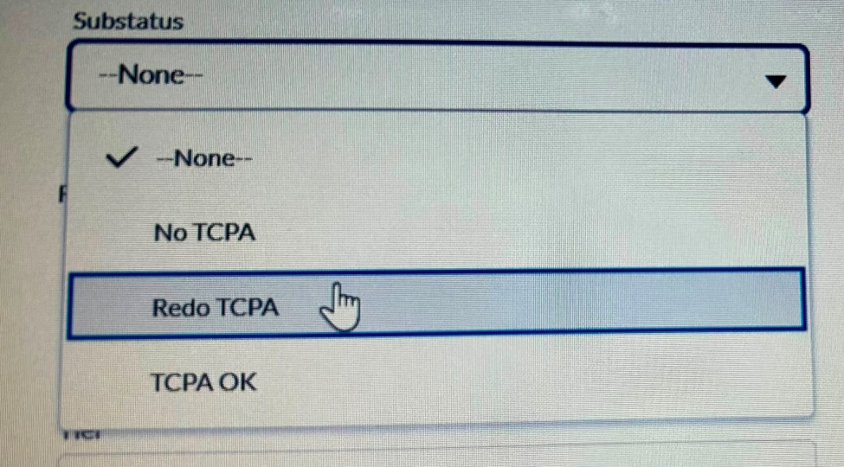

Date Subscribed
Format – Month/Date/Year (ex.12/31/2026) (SHOULD BE USED FOR ALL DATES)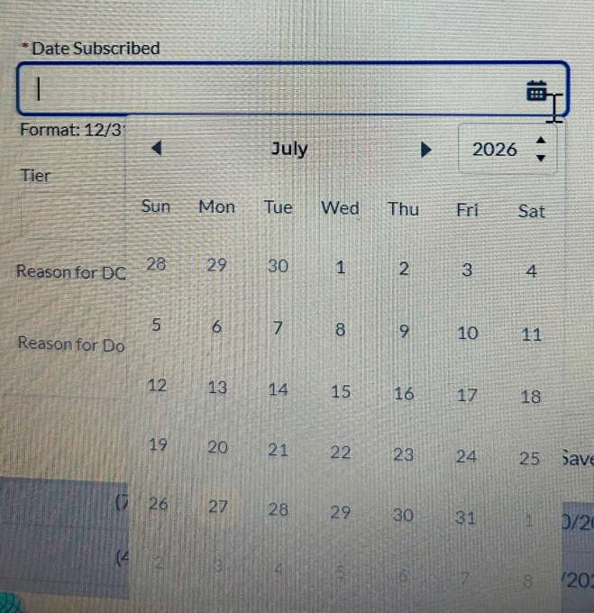

Contact Information
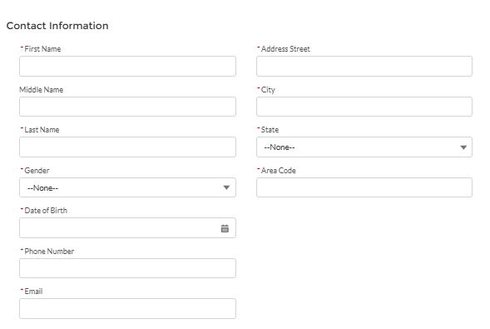
Gender (Drop Down Option)
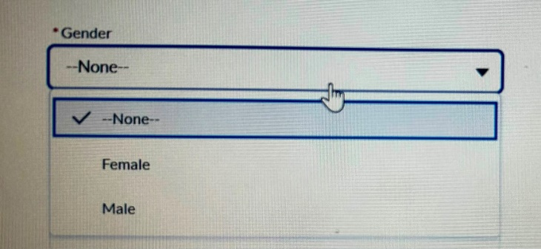

State (Drop Down Option)
(ALL US 50 STATES ABBREVATION SHOULD BE ADDED)
• AL
• AK
• AZ
• AR
• CA
• CO
• CT
• DE
• FL
• GA
• HI
• ID
• IL
• IN
• IA
• KS
• KY
• LA
• ME
• MD
• MA
• MI
• MN
• MS
• MO
• MT
• NE
• NV
• NH
• NJ
• NM
• NY
• NC
• ND
• OH
• OK
• OR
• PA
• RI
• SC
• SD
• TN
• TX
• UT
• VT
• VA
• WA
• WV
• WI
• WY
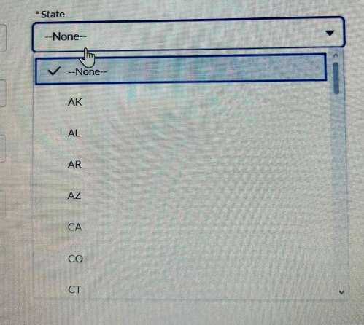

POA
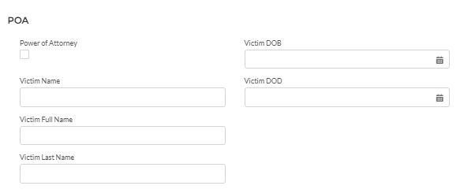
DIAGNOSIS INFORMATION
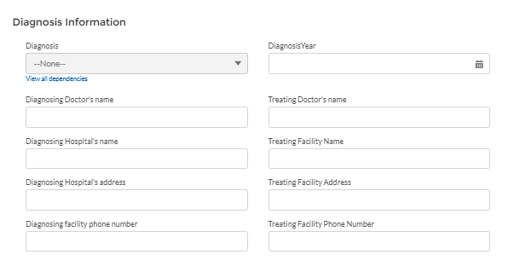
Q) Diagnosis (Drop Down Answer Options)
Sexual Dysfunction
PTSD (Post-Traumatic Stress Disorder)
Anxiety
Depression
Other
Pls add this Question before Diagnosis Ques/Option
Q)Which Incident occurred:- ( For answer Pls add drop down options below & they should be able select Multiple Options)
Sexually Assaulted In Person After Meeting Perpetrator
Sexual Grooming & Coerced to Send Sexual Images
Received Sexual Images from Abuser
Sexual Message/Communication & demanding for Nude Content
Offered Money, Gift Card, or Robux then Sexually Assualted

OTHER CASE INFORMATION

Other Case Information

Is this claim for you or someone else?
Myself
Loved One/Family Member
(If they select Option for Someone else then following ques should appear)
Who are you applying for?
(For Answer Pls add blank box)
How old was your Son/Daughter/Victim when this happened
For Answer (pls add Blank Box)
When did you first started using Roblox?
For Answer (pls add Date Selection)
When did this incident happen?
For Answer (Date Selection)
How much time did He/She/Victim spend on Roblox daily?
For Answer (pls add Blank Box)
Roblox Username of Son/Daughter/Victim
For Answer (pls add Blank Box)
Abuser’s Username of Son/Daughter/Victim
For Answer (pls add Blank Box)
Did your Son/Daughter/Victim communicate with the abuser outside of Roblox? If Yes! Mention which platform- For Answer (pls add following Options)
Snapchat
Discord
Instagram
Other
What was your Son’s/Daughter's/Victim Username on Snapchat/Instagram/Discord/Other Platform?
For Answer (pls add Blank Box)
What was Abuser’s Username on Snapchat/Instagram/Discord/Other Platform?
For Answer (pls add Blank Box)
Explain in detail what your Son/Daughter/Victim went through?
For Answer (pls add Big Blank Box)
Were any purchases made in Roblox during this time?
Yes
No
Other
Was this reported to Roblox Moderation,Police or Law Enforcement? If Yes whom was it reported to?
For Answer (pls add Blank Box)
Emotional Changes / Symptoms Before:-
For Answer (pls add Blank Box)
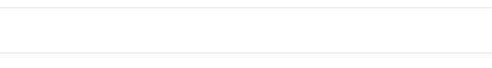
Symptoms Started Date :- For Answer (Date Selection)

How did they Confirmed your Diagnosis / Test before Diagnosis :-

Date of Test :- For Answer (Date Selection)

Treatment :-

Treatment Date :- For Answer (Date Selection)

Did you have any legal representation with any law firm regarding this claim?
Yes
No

Conviction Felony/Crime?
YES
NO

Do you have Medical Records?
Yes
No

